- Create a branch on GitHub Desktop
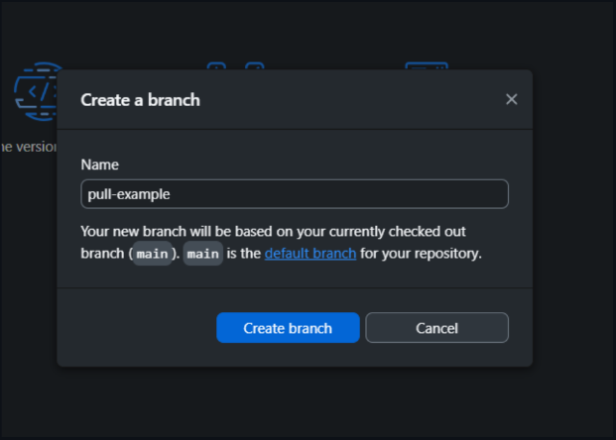

- Create a file in VSC and view on GitHub Desktop
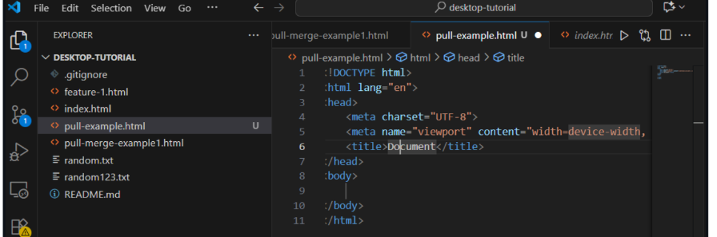
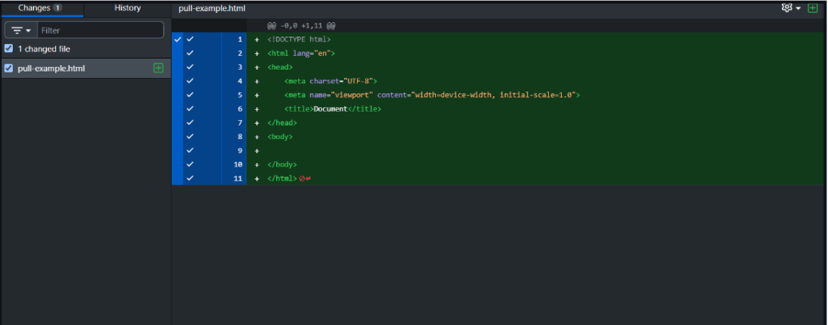

- Then modify the file in VSC, confirm the branch as “current” and commit onto the branch
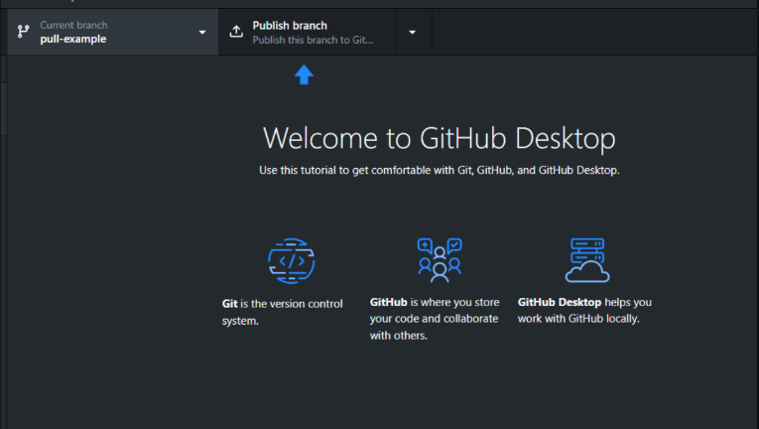
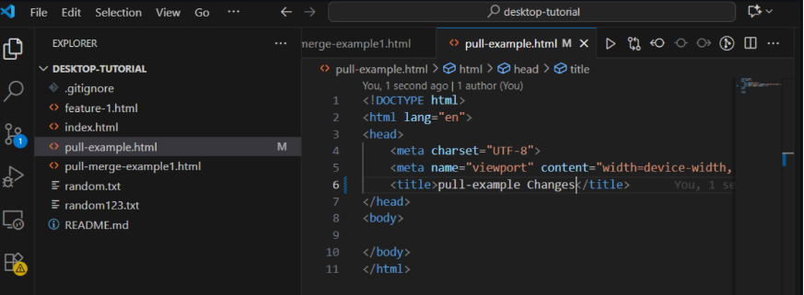
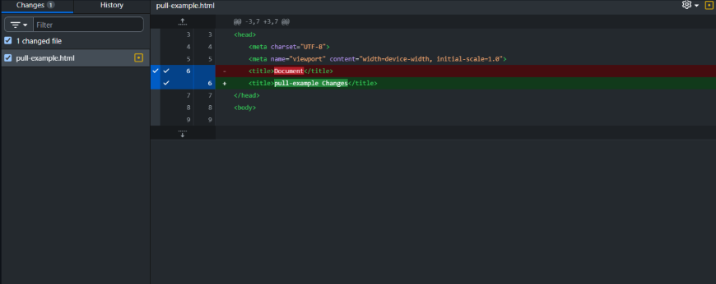

- Instead of merging the branch into main in GitHub desktop, publish the branch to GitHub.com

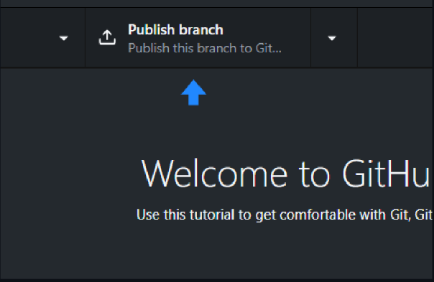

- On GitHub.com, create a pull request and approve – confirm Merge
